A Project Phase I Report on

EMPLOYEE PROMOTION USING MACHINE LEARNING AND DATA SCIENCE
Submitted to the Dept. of Information Technology, SNIST
in the partial fulfillment of the academic requirements for the award of

B-Tech (Information Technology)
under JNTUH
by
K. Vamshi Kiran (17311A1295)
G. Joshua Sunder Raj (17311A12A0)
L. Abhinay (17311A12A7)
under the guidance of
Dr. N. Divya
Assistant professor

Department of Information Technology
School of Computer Science and Informatics
SreeNidhi Institute of Science and Technology (An Autonomous Institution)
Yamnampet, Ghatkesar Mandal, R. R. Dist., Hyderabad – 501301
affiliated to
Jawaharlal Nehru Technological University Hyderabad
Hyderabad – 500 085
2020–21
Department of Information Technology
School of Computer Science and Informatics
Sreenidhi Institute of Science and Technology

Certificate

This is to certify that the Project Phase I report on “Employee Promotion using Machine Learning and Data Science” is a bonafide work carried out by
K. Vamshi Kiran (17311A1295), G. Joshua Sunder Raj (17311A12A0), L. Abhinay (17311A12A7) in the partial fulfillment for the award of B-Tech degree in Information Technology, Sreenidhi Institute of Science and Technology, Hyderabad, affiliated to Jawaharlal Nehru Technological University Hyderabad (JNTUH), Hyderabad under our guidance and supervision.
The results embodied in the Project Phase I work have not been submitted to any other University or Institute for the award of any degree or diploma.

Internal guide Project Coordinator Head of the Department
(Dr. N. Divya) (Dr. M. Sreenivas) (Dr. V. V. S. S. S. Balaram)

External Examiner
Date:
DECLARATION

We, K. Vamshi Kiran (17311A1295), G. Joshua Sunder Raj (17311A12A0)
L.Abhinay (17311A12A7), students of Sreenidhi Institute of Science and Technology, Yamnampet, Ghatkesar, studying Ⅳ^{th} year 1st semester, Information Technology solemnly declare that the Project Phase I work, titled “Employee Promotion using Machine Learning and Data Science” is submitted to Sreenidhi Institute of Science and Technology for partial fulfillment for the award of degree of Bachelor of technology in Information Technology.

It is declared to the best of our knowledge that the work reported does not form part of any dissertation submitted to any other University or Institute for award of any degree.

Acknowledgments

We would like to express our immense gratitude and sincere thanks to Dr. N. Divya, Assistant Professor in Information Technology for her guidance, valuable suggestions and encouragement in completing the Project Phase I work within the stipulated time.

We would like to express our sincere thanks to Dr. P. Narasimha Reddy, Executive Director, Dr. T. Ch. Siva Reddy, Principal, Dr. V. V. S. S. S. Balaram, Professor & Head of the Department of Information Technology, Dr.M. Sreenivas, Associate Professor & Project Phase I Work Coordinator of the Department of Information Technology, Sreenidhi Institute of Science and Technology (An Autonomous Institution), Hyderabad for permitting us to do our Project Phase I work.

Finally, we would also like to thank the people who have directly or indirectly helped us and parents and friends for their cooperation in completing the Project Phase I work.

K. Vamshi Kiran (17311A1295)
G. Joshua Sunder Raj (17311A12A0)
L. Abhinay (17311A12A7)

ABSTRACT
“PREDICTING EMPLOYEE PROMOTION USING ML AND DATA SCIENCE”
There are several areas in which organizations can adopt technologies that will support decision-making: artificial intelligence is one of the most innovative technologies that is widely used to assist organizations in business strategies, organizational aspects, and people management. In recent years, attention has increasingly been paid to human resources (HR), since worker quality and skills represent a growth factor and a real competitive advantage for companies. After having been introduced to sales and marketing departments, artificial intelligence is also starting to guide employee-related decisions within HR management. The purpose is to support decisions that are based not on subjective aspects but on objective data analysis. The goal of this work is to analyze how objective factors influence employee attrition, in order to identify the main causes that contribute to a worker’s decision to leave a company, and to be able to predict whether a particular employee will leave the company. After the training, the obtained model for the prediction of employee’s attrition is tested on a test dataset.

K. Vamshi Kiran (17311A1295) Project Guide:

G. Joshua Sunder Raj (17311A12A0) Dr. N. Divya

L. Abhinay (17311A12A7) Assistant Professor

IV-II (2021), Dept. of IT, SNIST Dept. of IT, SNIST

 | LIST OF FIGURES
S. No | Fig. No | Title of Figure | Page. No
1 | 1.1 | Architecture Diagram | 6
2 | 1.2 | Use Case Diagram | 7
3 | 1.3 | Sequence Diagram | 8
4 | 1.4 | Activity Diagram | 9
5 | 2.1 | Class Imbalance | 11
6 | 2.2 | Description of the data | 11
7 | 2.3 | Pie chart | 12
8 | 2.4 | Distribution of Employee ages on Histogram | 12
9 | 2.5 | Count plot of No of Training's Taken | 13
10 | 2.6 | Count plot of employees present in each department | 13
11 | 2.7 | Distribution of training score | 14
12 | 2.8 | Effect of Gender and department on promotion | 15
13 | 2.9 | Effect of education on promotion | 16
14 | 3.1 | Bivariate Analysis of service length on promotion | 17
15 | 3.2 | Correlation heat map | 18
16 | 3.3 | Group by Function | 20
17 | 3.4 | Interactive widgets | 20
18 | 3.5 | Label encoding | 21
19 | 3.6 | Splitting of Data | 21
20 | 3.7 | Resampling | 22
21 | 3.8 | Feature Scaling | 23
22 | 3.9 | Decision Tree Model | 23
23 | 4.1 | Decision Tree report | 24
24 | 4.2 | Decision Tree Feature Importance | 24
25 | 4.3 | Logistic Regression Model | 25
26 | 4.4 | Logistic Regression Feature Importance | 25
27 | 4.5 | Random Forest Classifier Report | 26
28 | 4.6 | Random Forest Classifier Feature Importance | 26
29 | 4.7 | Testing on Test Data | 27

INDEX

- ABSTRACT I

- LIST OF FIGURES II

- INTRODUCTION
- Motivation 1
- Problem Definition 1
- Objective of Project 1

- LITERATURE SURVEY
  - Existing System 2
  - Proposed System 2

- SYSTEM ANALYSIS
  - Functional Requirements Specifications 3
  - Software Requirements 3
  - Hardware Requirements 3

- SYSTEM DESIGN
  - Architecture of Proposed System 4
  - Use case Diagram 5
  - Sequence Diagram 6
  - Activity Diagram 7

- IMPLEMENTATION 8-10
- OUTPUT SCREENS 11-27
- CONCLUSION AND FUTURE SCOPE 28
- REFERENCES 29

Introduction
Motivation
In today’s competitive economy and its growing technological specialization, acquisition, study and analysis of data are giving rise to new knowledge, referred to as “knowledge economy”. Information technologies are not only a source of data but are, above all, an enabling factor for data analysis, making it possible to process large data collections and allow information to be extracted from them. In fact, analyzing large amounts of data can lead to improvements in decision-making processes, the achievement of per-established corporate objectives and better business competitiveness.
Companies invest a lot of time and resources in employee recruiting and training, according to their strategic needs. Therefore, the employees (to a greater or lesser extent) represent a real investment for organizations. When an employee leaves the company, the organization is not only losing a valuable employee, but also the resources, specifically money and HR staff effort, that were invested recruiting and selecting those employees and training them for their related tasks.
Definition
Organizations need to focus much on investing in an efficient training system. The problem that the study projects to focus on is the prediction of the necessity of training to assist in retaining the most talented staff. The key focus of the study is to predict the resigning employee to improve retention. It, therefore, means that the research focuses on the training aspect, an area that most companies have neglected, but is essential for employee satisfaction. To establish the most appropriate element for the organization and the specific talent that the company needs to maintain, the study formulated the approach to project employee training.
Objective
To identify the talents which the company wants to develop and maintain to predict employee training. To determine the first-hand productive analysis techniques and implementation in a real-world scenario. To highlight who is eligible to be retained in the company and have a successful career path. To identify the employee retention rate in the organization under the study.
The project is especially useful to the Human Resources Department, in accurately determining the employees to be promoted. The project is also useful to the hard-working employees, as their efforts are properly recognized by the tool, while determining the promotions.

LITERATURE SURVEY
Existing System
According to Ala (2013), Decision Trees are tree-shaped structures, which represent decision sets, and employ decision algorithms for mining data. The technique is also applicable in exploring the potential impacts of diverse inputs. Therefore, Alao (2013) explained that predictive analytic s is primarily concerned with the prediction of the future by utilizing current and past data

Bischl (2016) explained that in an under-sampling, there is a random replication of the majority category employed in training. Oversampling randomly replicates cases of the minority category.

The Support vector machine approach is essential since it performs class categorization by establishing a division point for categorizing in the high dimensional space of a hyperplane. B-Gent (2006) explained that the larger the edge, the lower the inaccuracy of the classifier, and the error.

According to Raschka (2017), the algorithm relies on condition-based learning. Characterization is also obtained from the fundamental significant part vote of the k-closest neighbors of every point.

According to Rashcka (2017), logistic regression is a machine learning calculation for characterization. The estimation considers the possibilities that elucidate the potential outcomes of a separate trial, and they are represented using a logistic Regression.

Proposed System
Using Machine Learning technique, more specifically Predictive Analytic s, we can predict the employee attrition. Predictive analytics is the practice of extracting information from existing data sets to determine patterns and predict future outcomes and trends. Using Python, which is chosen as the best programming language, by the Programming Community. More Functionality can be implemented with less no of lines of code in Python.

SYSTEM ANALYSIS

Functional Requirements Specifications
After analyzing the project objective, we have come up with following modules:

User Module:
- In this module the user will be available to access the website. The user can see the front-end part, will be able to select the image and upload the image. After uploading the results can be seen by the user.

Software Requirements
    - WEB BROWSER
    - 64-bit Operating System: Windows 7 or Higher
    - Python version >3.0
    - Libraries: sweet-viz, Pandas, Numpy, Scipy, matplotlib, seaborn, ipywidgets.

Hardware Requirements
      - System with Windows 10/Ubuntu Operating System
      - RAM preferably >8GB for faster processing
      - Memory space >2GB

SYSTEM DESIGN

Architecture of Proposed System

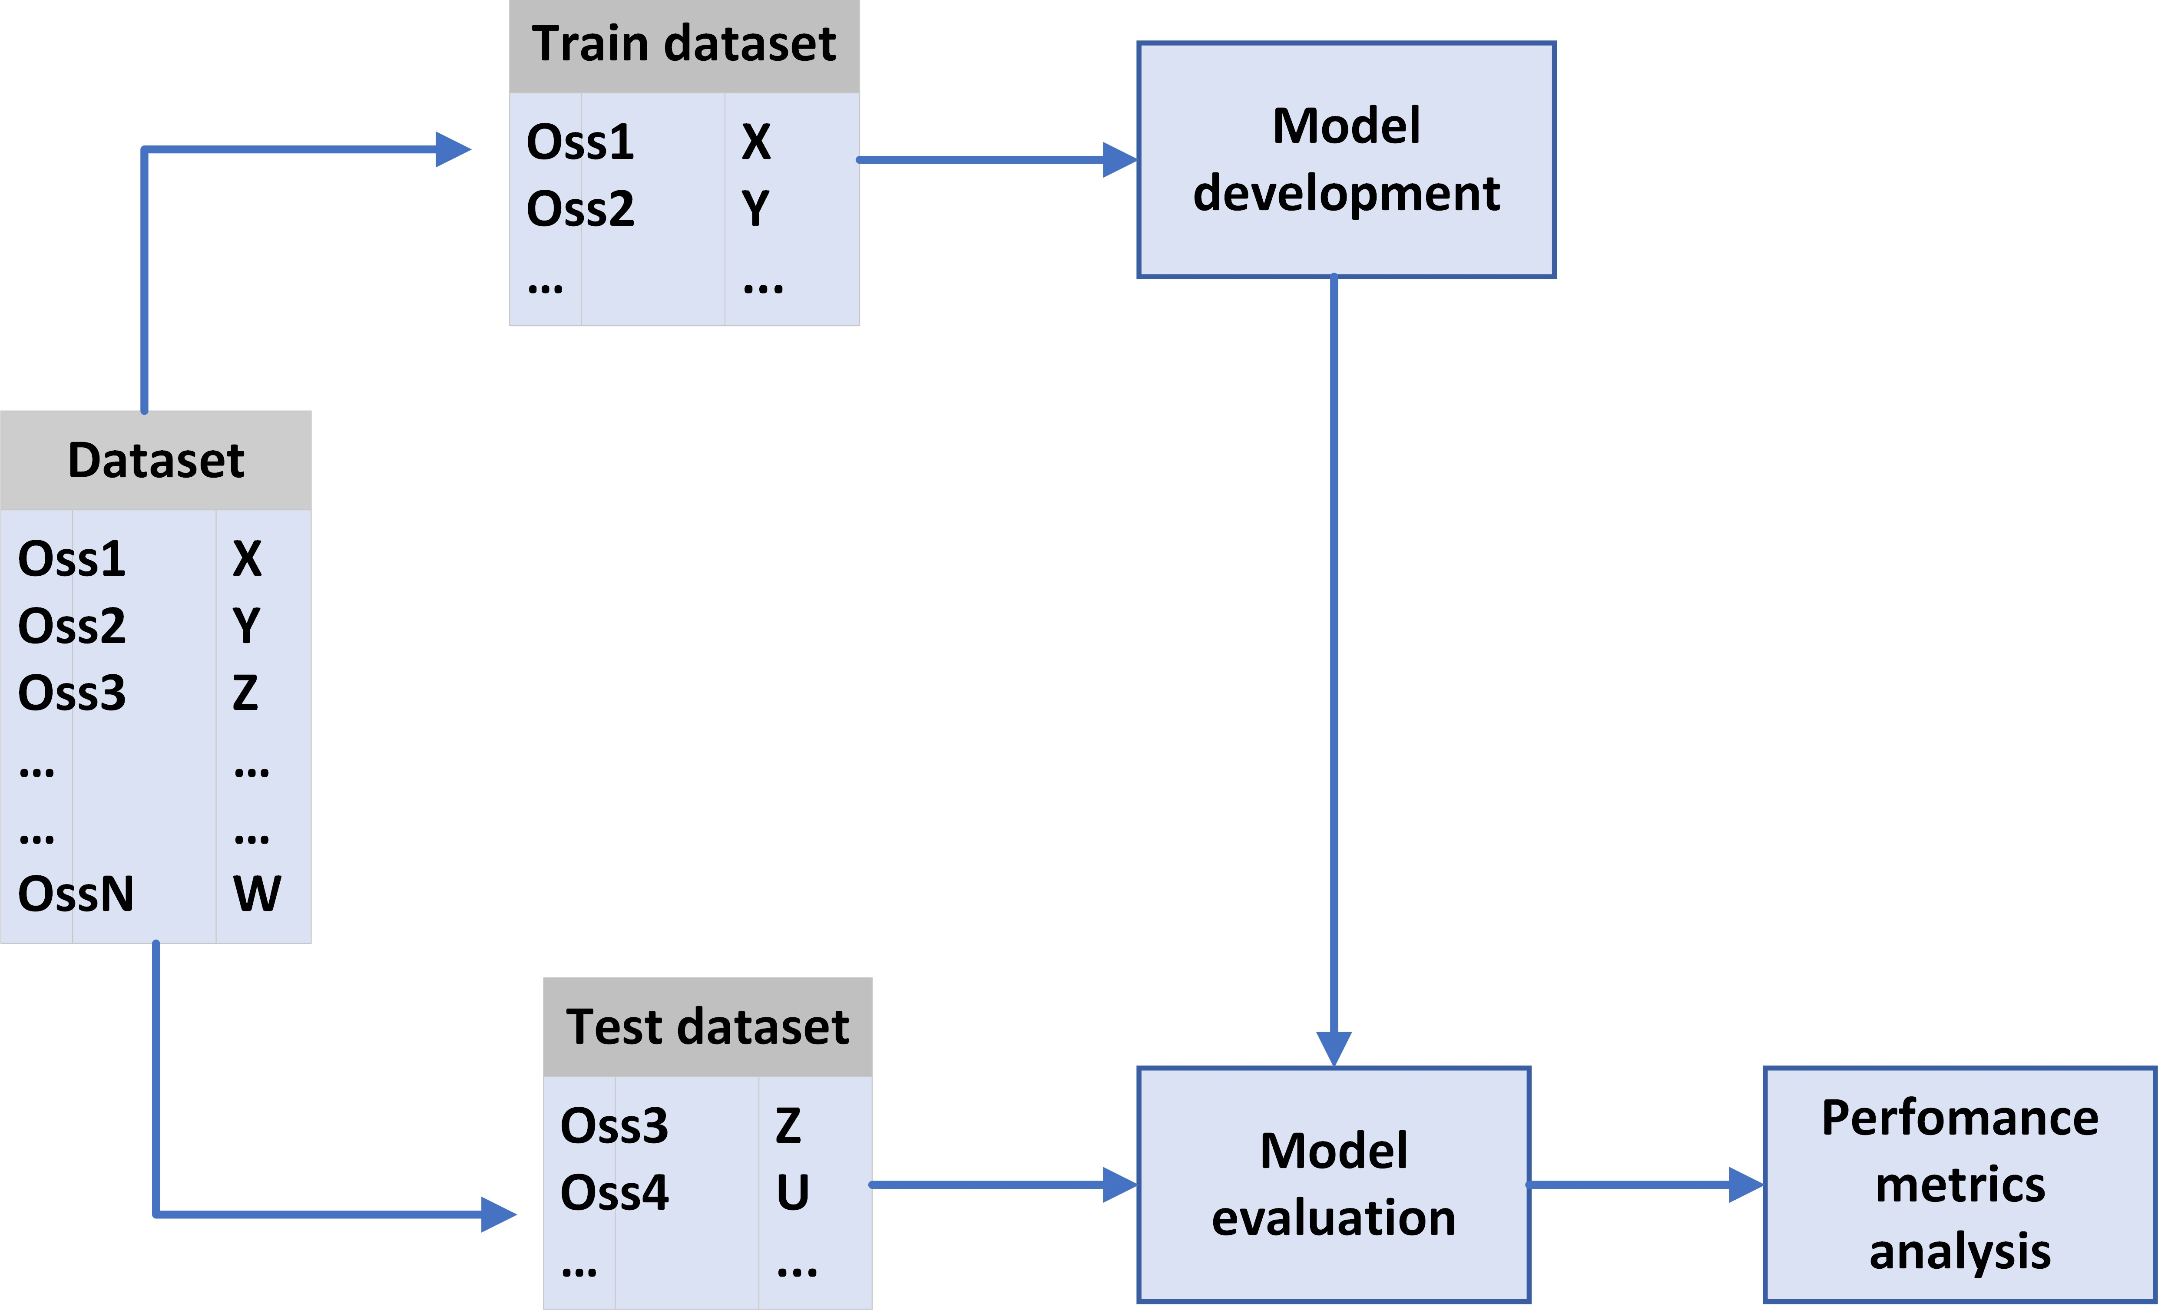
Fig 1.1: Architecture Diagram

The architecture of the model states the steps that are involved in the model evaluation. In this architecture we have various steps in a way the model is evaluated and each steps undergoes different operations.

- Selection of Dateset: In this step the dataset is chosen, and the dataset chosen about all the details of the employee.

- Extracting Features in Background: We need to Train the data to create a model. This step ensures that our model is trained accurately. Feature extraction involves reducing the number of resources required to describe a large range of data. All the required features are extracted from the dataset taken.

c. Employee Promotion: After the classification, the model is built by the training dataset and the results are validated. In this stage the image is validated and the output is generated is detected if the employee is eligible from promotion or not.

UML Diagrams
Use Case Diagram
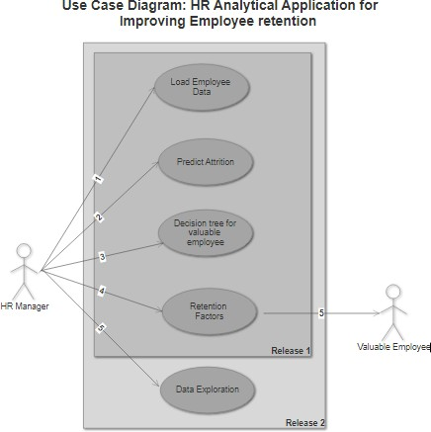

Fig 1.2: Use Case Diagram

The data is perfectly fed into the system and attrition is predicted with the expected accuracy. The employees who are going to resign from the company are then categorized into valuable and ordinary employees using decision tree. The most effective retention factors for valuable employees are then displayed on the dashboard.

4.2.2 Sequence Diagram

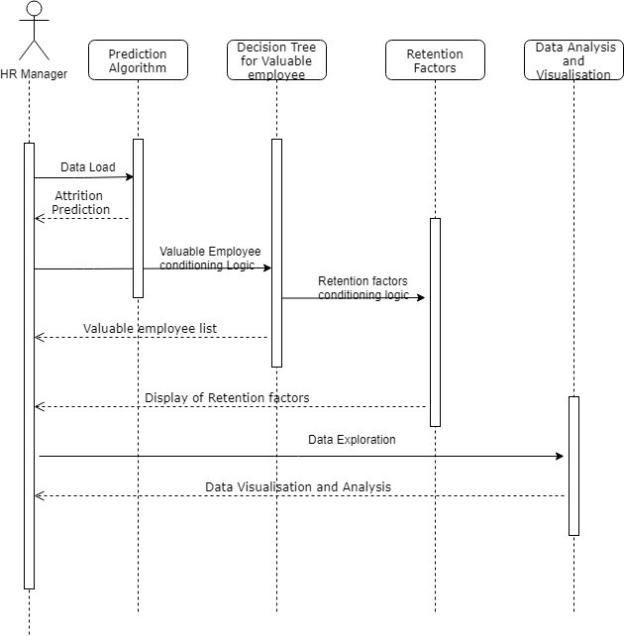
Fig 1.3: Sequence Diagram

Sequence diagram demonstrates the sequence of action performed during the run time of an application. The below diagram shows, how the user sends the request to each block of code and receives the output in return.

4.2.3 Activity Diagram
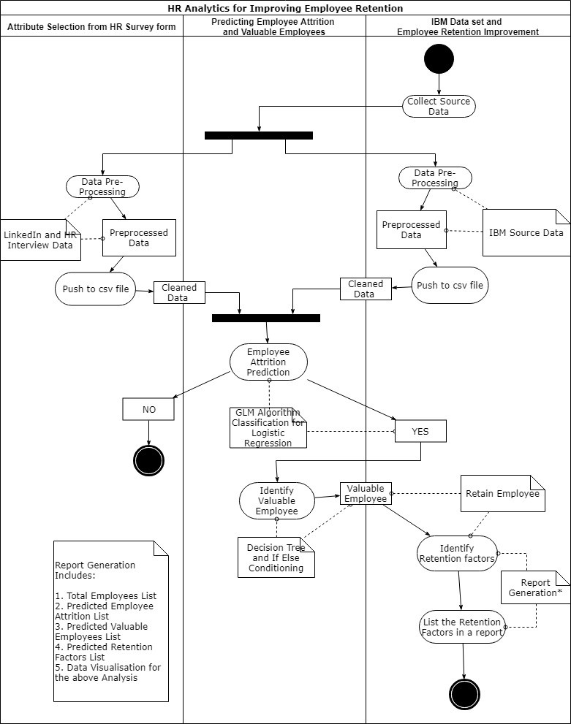
Fig 1.4: Activity Diagram

The system design can be explained with the help of the following UML Diagram which represent the working of the Analytical Application

Implementation

Concept
In this research, various supervised machine learning algorithms are described, demonstrated, and assessed in their ability to predict employee turnover. This section provides a general overview of the theory behind these algorithms.

Implementation of Model

Before starting any classification project selection of dataset must be the first step. We can select the dataset which is already available in various websites like kaggle.com or we can prepare our own dataset. We should be incredibly careful while selecting our data. After selecting the dataset now, we should build test cases. We should separate the dataset into testing data and training data. While building testing and training data we should be careful, and we should take care such that all the possible edge cases and constraints are present in both the datasets. So, that our model gets trained well and gives accurate results when encountered real world problems.

Source of the Dataset:
Kaggle Data repository
The dataset consists of 54808 Observations with 13 Features including Target variable.

Algorithms Implemented:
- Data preprocessing:
After selecting the dataset, we need to preprocess the dataset. Data preprocessing is a technique which is used to transform the data such that the machine learning model can understand the data we need to encode and parse the data such that any errors or outliners or missing values are eliminated. In this project we need to transform the data such that it is acceptable by neural networks. Because the dataset contains variables like normal, pneumonia which are written in string format, so we need to convert them into binary vectors. We need to map the categorical values to integer values.

Data preparation is one of the most important aspects of machine learning; it is usually complex and often requires rather a lot of time. In fact, it has been calculated that on average this operation requires 60% of the time and energy spent on a data science project. Therefore, attention should be paid to the preliminary stages of Business Understanding and Data Understanding, which will simplify the next stages of the process. The first performed activity was the data selection: the data relevant to the target was selected from the initial dataset; characteristics considered less significant or redundant were removed. Then, “null” and “undefined” values or duplicate records were identified, since they could inadvertently influence the correct training of the model and, consequently, produce inaccurate predictions. No null or undefined values were found in any variable and no duplicate observations emerged. In addition, the qualitative variables were transformed into quantitative variables: the categorical data were converted into numbers so that the machine learning model could work. The original dataset in fact contained several variables with textual values (“Age”, “Department”, “Average Rating score”, “Gender”, “total score”, “Length of Service”, “Sum metric” and “kpi met >80%”).

After completing the above steps our dataset is ready for training the system. Now we are going to use Predictive models to build the model. Predictive modeling uses statistics to predict outcomes. Most often the event one wants to predict is in the future, but predictive modeling can be applied to any type of unknown event, regardless of when it occurred. For example, predictive models are often used to detect crimes and identify suspects, after the crime has taken place.

- Logistic Regression:

It is a traditional classification approach used to assign observations to a particular class. It transforms its output using a logistic sigmoid function to return a probability value that can be mapped to a class. It is a widely used classifier that is easy to implement and works well on linearly separable classes.

- Decision Tree:

It is a supervised learning approach that builds a classification model in a tree structure. It makes classification rules by using the top-down approach. It makes sequences of rules which is used to determine the class of a new observation. It uses post pruning methods to handle over-fitting problems.

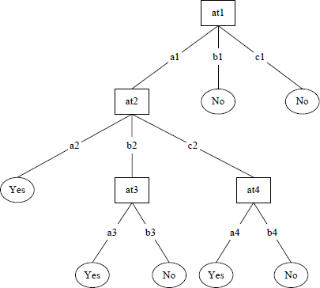

- Random Forest:
It consists of many individual decision trees that are used to train data. Each tree in a random forest spits out a class prediction, and the class with the most votes become the model’s prediction. It uses an ensemble approach that provides an improvement over basic tree structure. It combines various weak learners to form an active learner. Ensemble methods are based on the divide and conquer approach to improve performance.

Output Screens

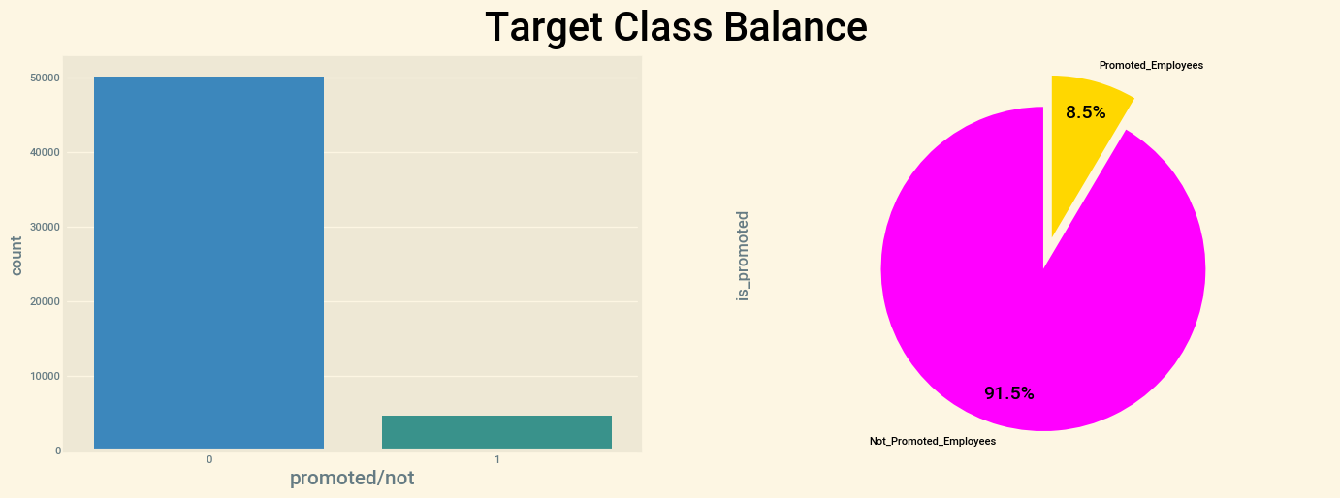
Fig 2.1 Class Imbalance
As we can see there is a Huge Data Imbalance between the promoted employees and those who are not, so in order to balance the target classes, we need to balance the target class. whenever we use a machine learning model there will be a high chance of getting poor results and the results can be biased to the class having higher distribution. So, to this we can use something called RESAMPLING METHODS.

UNDER SAMPLING: It is the method of eliminating the values from the higher class, so as to bring the higher class to that of smaller one and make it EQUAL.
OVERSAMPLING: Its is a method of bringing the lower class equal to that of upper class, i.e Adding the values so as to make it equal to that of higher class.
Checking the descriptive statistics for Numerical Columns we check for stats such as Max, Min, Mean, count, standard deviation, 25 percentile, 50 percentile, and 75 percentiles.
For Categorical Columns we check for stats such as count, frequency, top, and unique.
54808.000000 | 54808.000000 | 50684.000000 | 54808.000000 | 54808.000000 | 54808.000000 | 54808.000000 | 54808.000000
1.253011 | 34.803915 | 3.329256 | 5.865512 | 0.351974 | 0.023172 | 63.386750 | 0.085170
0.609264 | 7.660169 | 1.259993 | 4.265094 | 0.477590 | 0.150450 | 13.371559 | 0.279137
1.000000 | 20.000000 | 1.000000 | 1.000000 | 0.000000 | 0.000000 | 39.000000 | 0.000000
1.000000 | 29.000000 | 3.000000 | 3.000000 | 0.000000 | 0.000000 | 51.000000 | 0.000000
1.000000 | 33.000000 | 3.000000 | 5.000000 | 0.000000 | 0.000000 | 60.000000 | 0.000000
1.000000 | 39.000000 | 4.000000 | 7.000000 | 1.000000 | 0.000000 | 76.000000 | 0.000000
10.000000 | 60.000000 | 5.000000 | 37.000000 | 1.000000 | 1.000000 | 99.000000 | 1.000000
Fig 2.2 Description of the data.
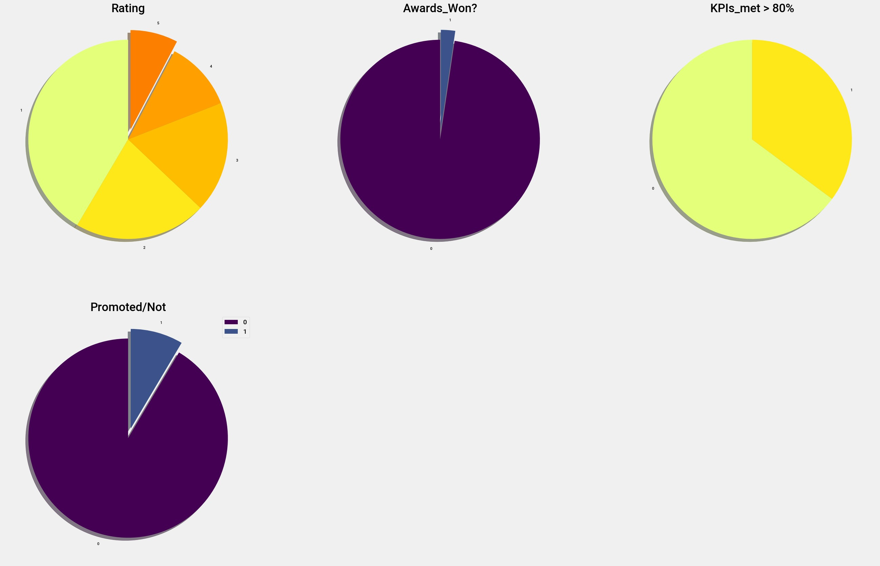

Fig 2.3 Pie Chart of Distribution of Important columns
By seeing the above Charts we can come to a conclusion that, Most of The employees are getting very Low ratings.
Very Few Employees have Won the Awards Recently(2%), like it is very low in a company of employees around 50000+. Well, KIP'S Met are very negligibly good when compared to other aspects.
Lastly, Assuming Overall Employee Performance Chart, Not more than 10% of Employees are getting promoted As expected by their performance.

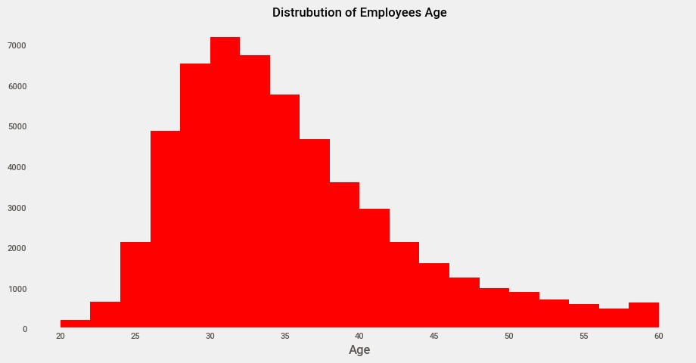

Fig 2.4 Distribution of Employees Age on Histogram

Above is the Count Plot for distribution of age among the employees which shows the count of employees ages present in the dodge dataset. We can see that employees with age group of 30's are more in number when compared to other age groups, this shows that there are some experienced workers or employees in the organization.
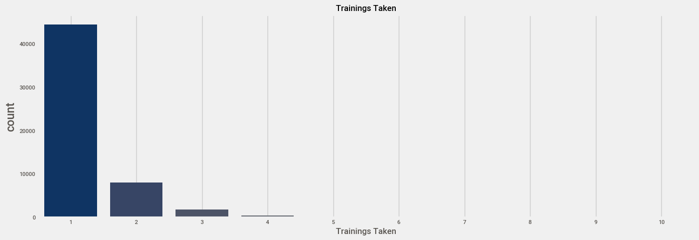

Fig 2.5 No of Training's taken by employees.
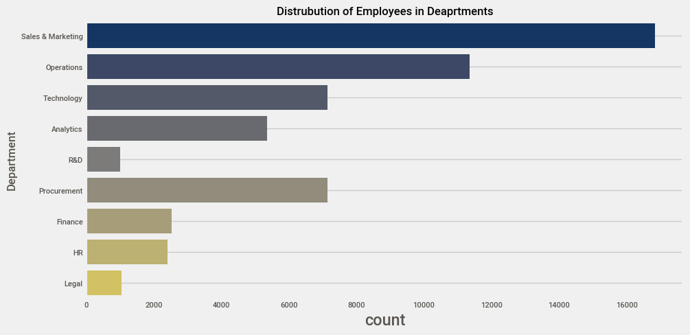

Fig 2.6 Count Plot of No of Employees Present in each department

Above Count plot shows the distribution of employees among different departments present in the organization.
we can see that Sales & Marketing department is ruling the organization which has got more number of employees working on it, along with Operation, Technology, Analytic so on..

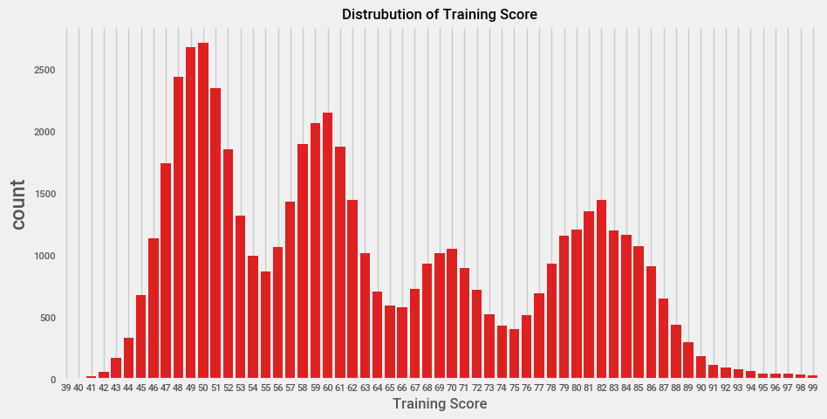

Fig 2.7 Distribution of Training Score

BIVARIATE ANALYSIS
Bi-variate Analysis is technique of analyzing 2 or more columns at a time, Due to this we can make significant findings, to find how does this columns affect our employees promotion status and to find the relationship between both the variables/columns.

Types of Bi-variate Analysis:
- Categorical vs Categorical
- Numerical vs Categorical
- Numerical vs Numerical
- First, we will perform Categorical vs Categorical Analysis using Grouped Bar Charts with the help of cross tab function.
- Second, we will perform Categorical vs Numerical Analysis using Bar Charts, Box plots, Strip plots, Swarm plots, Boxen plots, etc Atlast, we will perform Numerical vs Numerical Analysis using Scatter plots
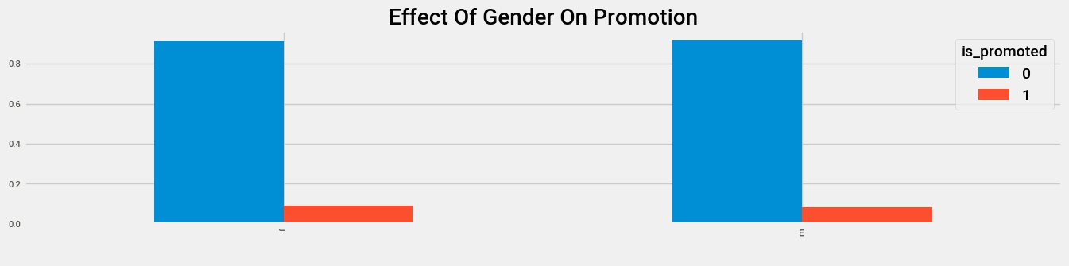

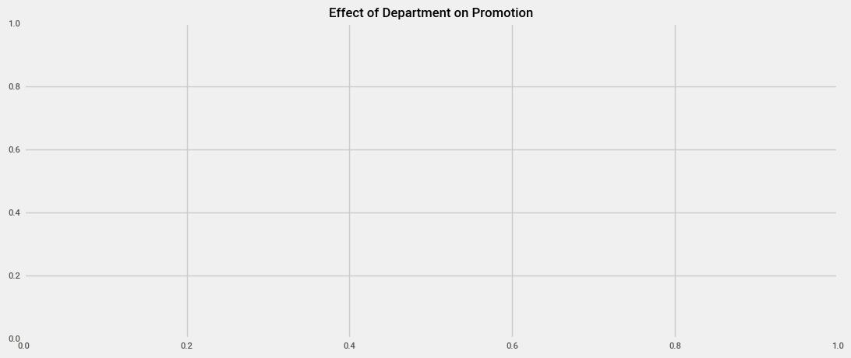
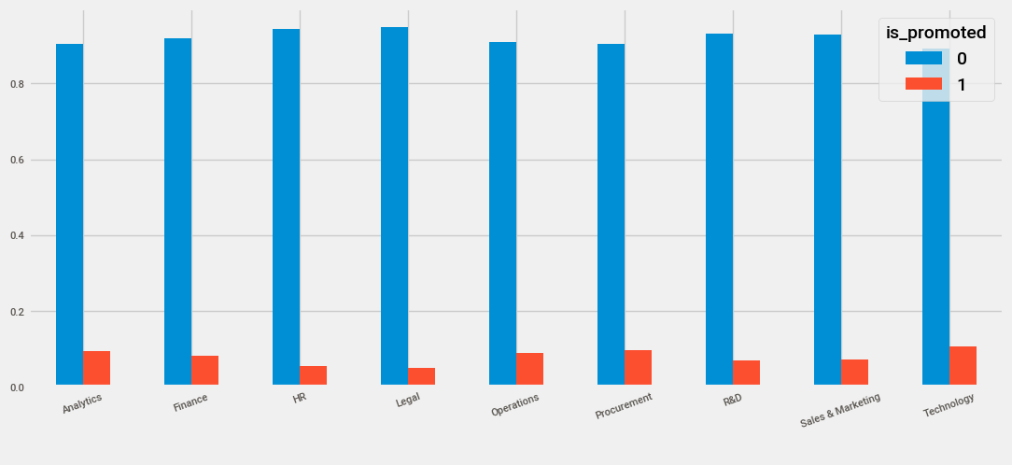

Fig 2.8 Bi variate Analysis of Effect of Gender and Department on Promotion

There isn't much difference of getting promoted based on the departments, where every department has different process and almost every department has equal number of people getting promoted.
Although Technical and procurement employees are topped in the list.

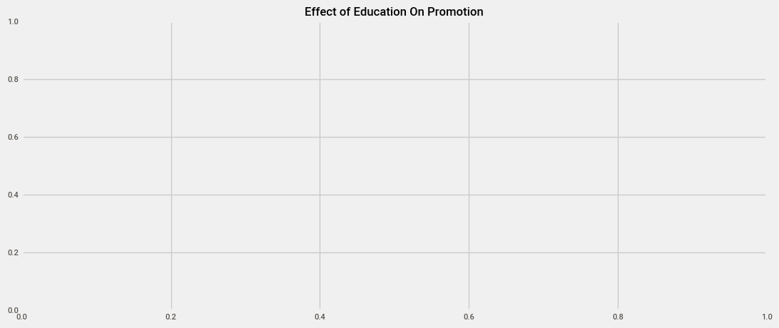
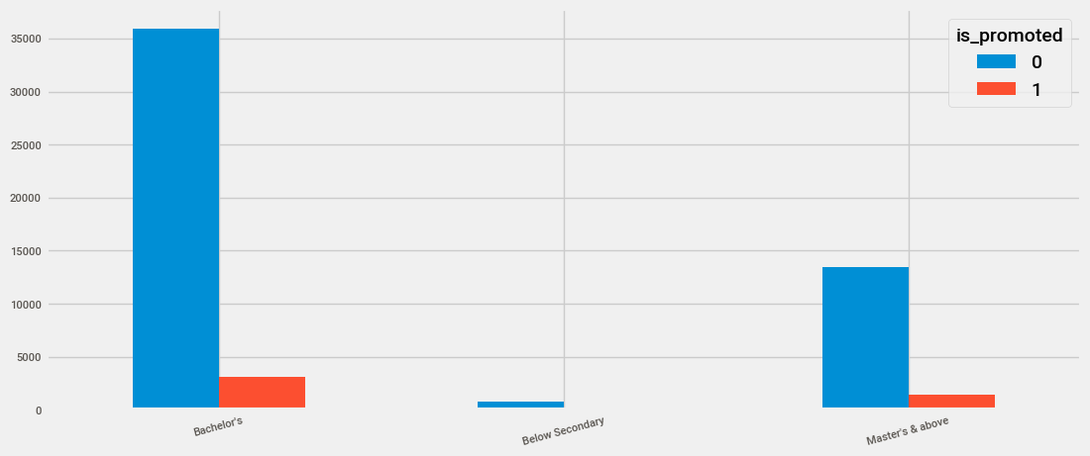

Fig 2.9 Effect of Education of Promotion

It is clearly shown that Employees Owing Bachelor’s degree are most likely to get promoted comparatively to other two educations.
As Expected there aren't many Employees with Below Secondary Degree who are likely in the race for Promotion, Because Most of the employees/People are showing Interests towards further studies rather than working after their Below Secondary Education.
Employees owning Masters degree are also negligibly high to get promoted, as there aren't many employees with that Master's who have somewhat more advanced knowledge that other two.

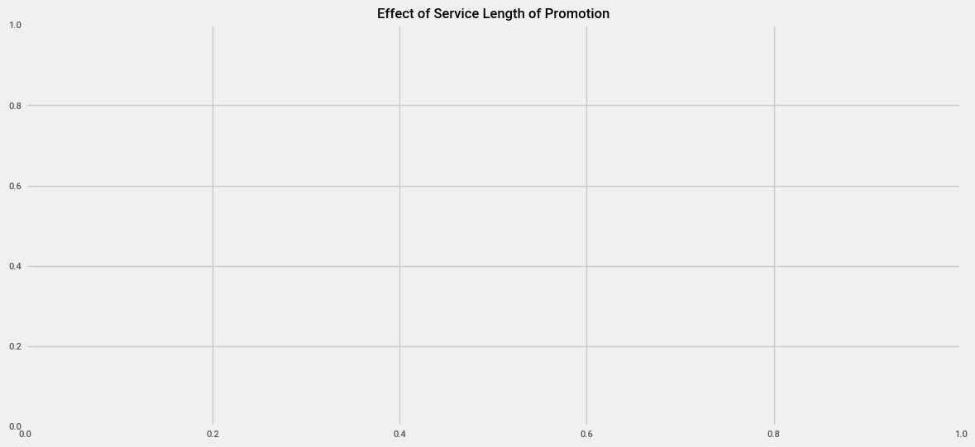
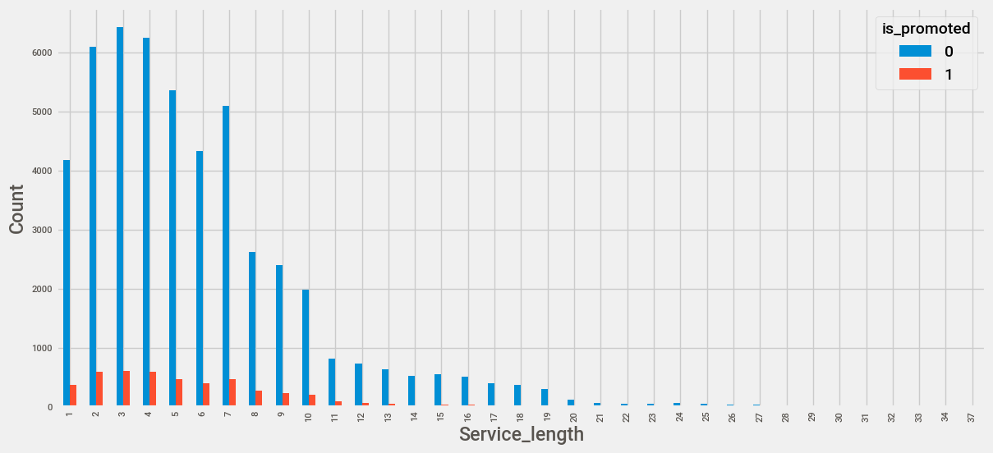

Fig 3.1 Bi variate Analysis of service length on promotion

It is clearly visible that the Company is not giving first Priority to the employees with ample amount of Work Experience they have in the organization, but mostly they are going for employees with negligible experience to give Promotion.

Multi Variate Analysis:

In this instance, a multivariate analysis would be required to understand the relationship of each variable with each other.

First, we will use the Correlation Heat-map to check the correlation between the Numerical Columns.
Then we will check the pp-score or the Predictive Score to check the correlation between all the columns present in the data.

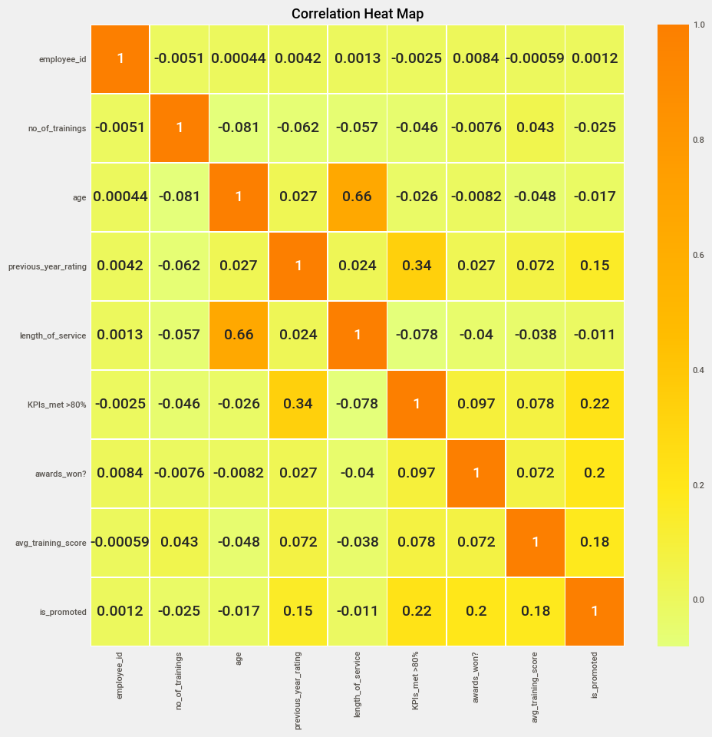

Fig 3.2 Correlation Heat Map (Multi variate Analysis)

Through the above heat map we can see that their is a correlation between age and length of service employees, obviously if an employee with age 50 years would have work experience of around 20 years, but an employee with 25 years would not have that much experience so, he might not be a part of the organization.
Not only Age and Length of Service, We also have correlation between Kip's Met and Previous Year ratings.

Feature Engineering is the Technique of using Domain Knowledge in order to extract the important features from the dataset using some data mining techniques.
These features can in turn help us to create/build an efficient Machine Learning Model.

Now, there are lot of methods/techniques to perform feature engineering such as.
People in the industry consider it has a most important step, due to the important information it will provide by the features extracted. Before Starting a Project one need to thoroughly understand each and every column present in the dataset, in order to extract some new features from the old existing features.
Different ways of extracting features from the dataset.
- We can remove unnecessary columns from our dataset.
- we can perform Binning method on Numerical and Categorical columns.
- we can extract features from date and time features.
- we can extract features from the categorical columns.
we can even perform aggregation on two/more columns together using some aggregation.

Grouping and Filtering:
Grouping is the fundamental concept and very important function in clustering techniques.
They are used to find the collections of entities and the relationships they have between each other. Grouping and filtering is considered as one of the important steps in analyzing/investigating the data. It helps in taking important decisions using filters and group-by functions.

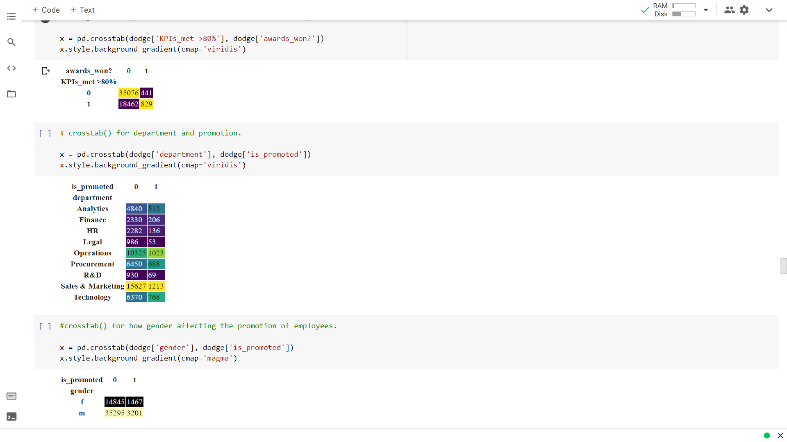
Fig 3.3 Group-by function.
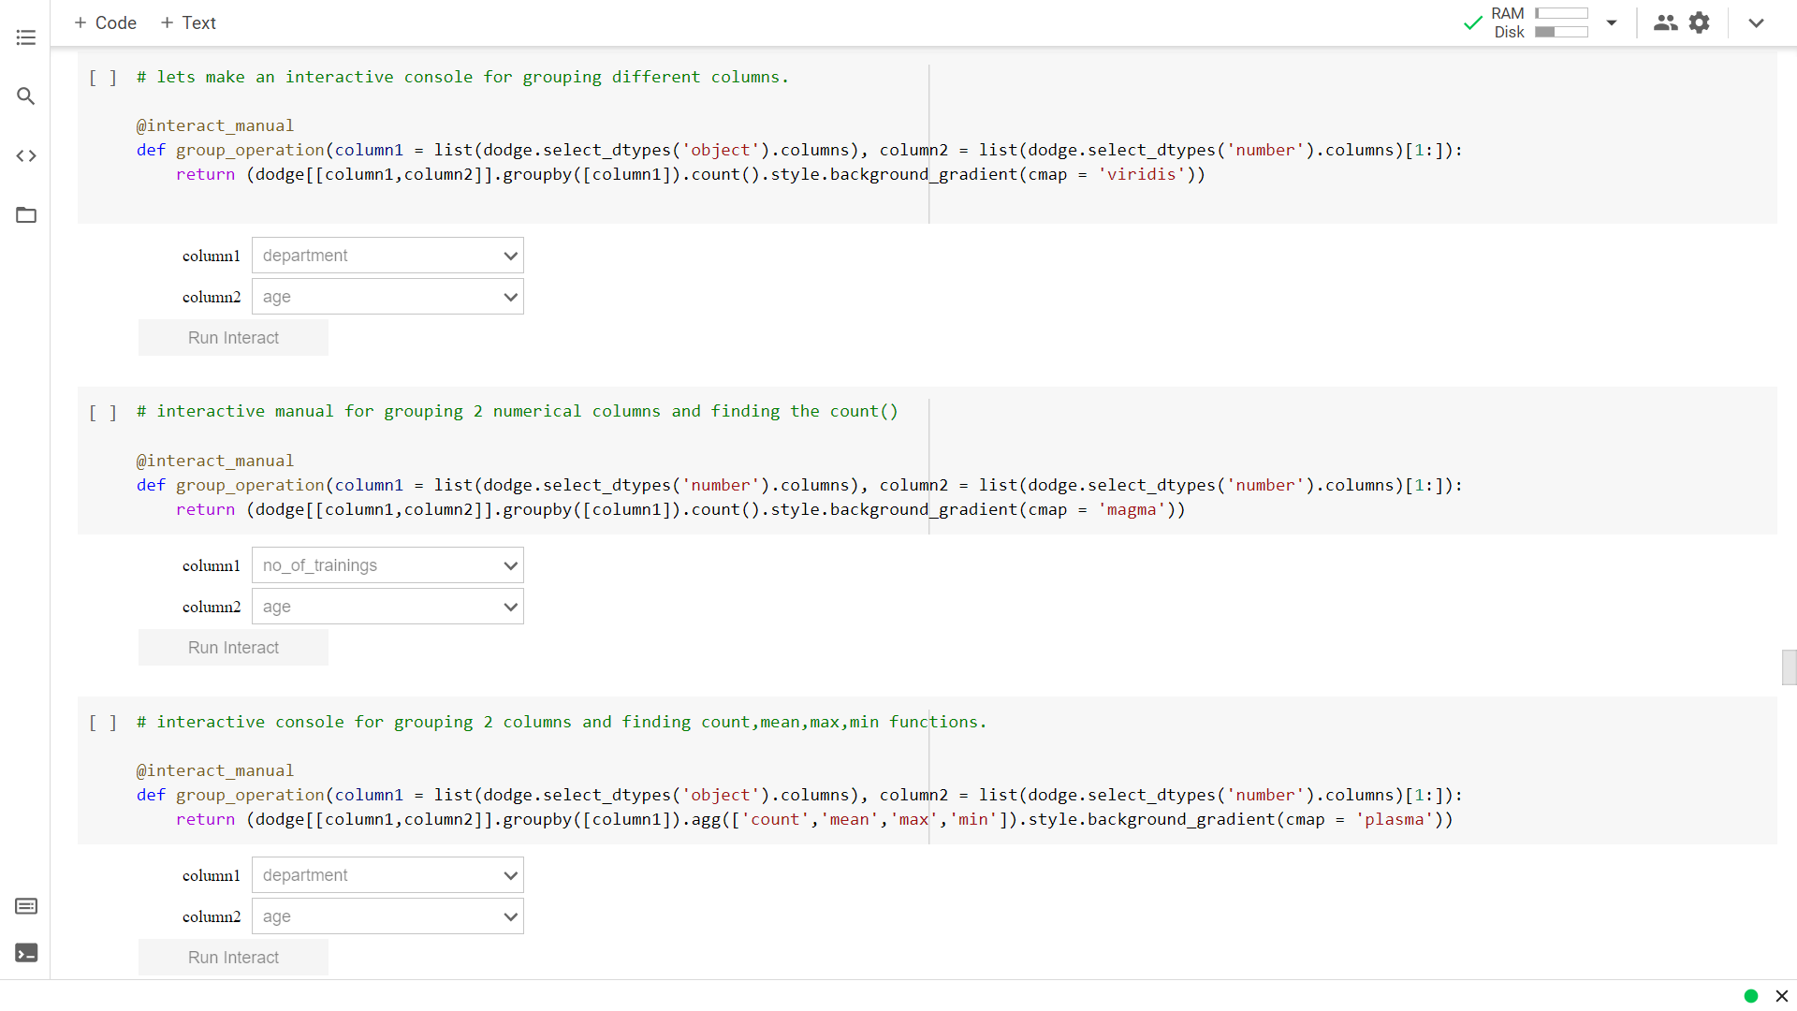
Fig 3.4 Interactive Widgets.
Label Encoder
- Encode target labels with value between 0 and n_classes-1.
- it will first identify the strings in the columns and sorts them in ascending order then assigns the string with a number from (0 to n classes-1).
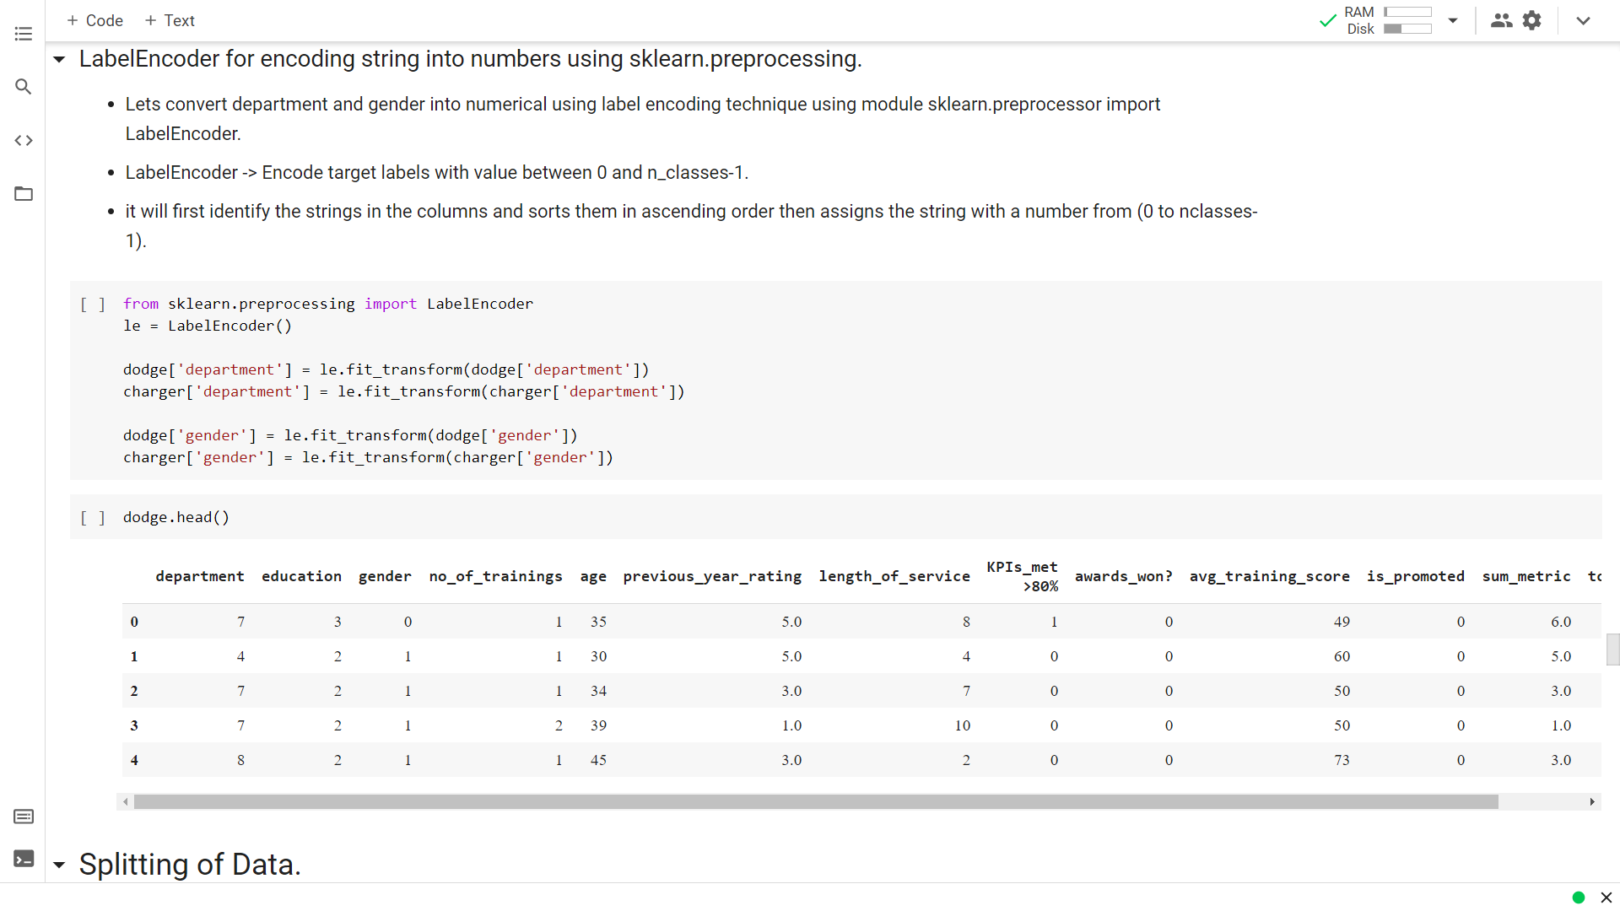
Fig 3.5 Label Encoding Categorical columns to Numerical

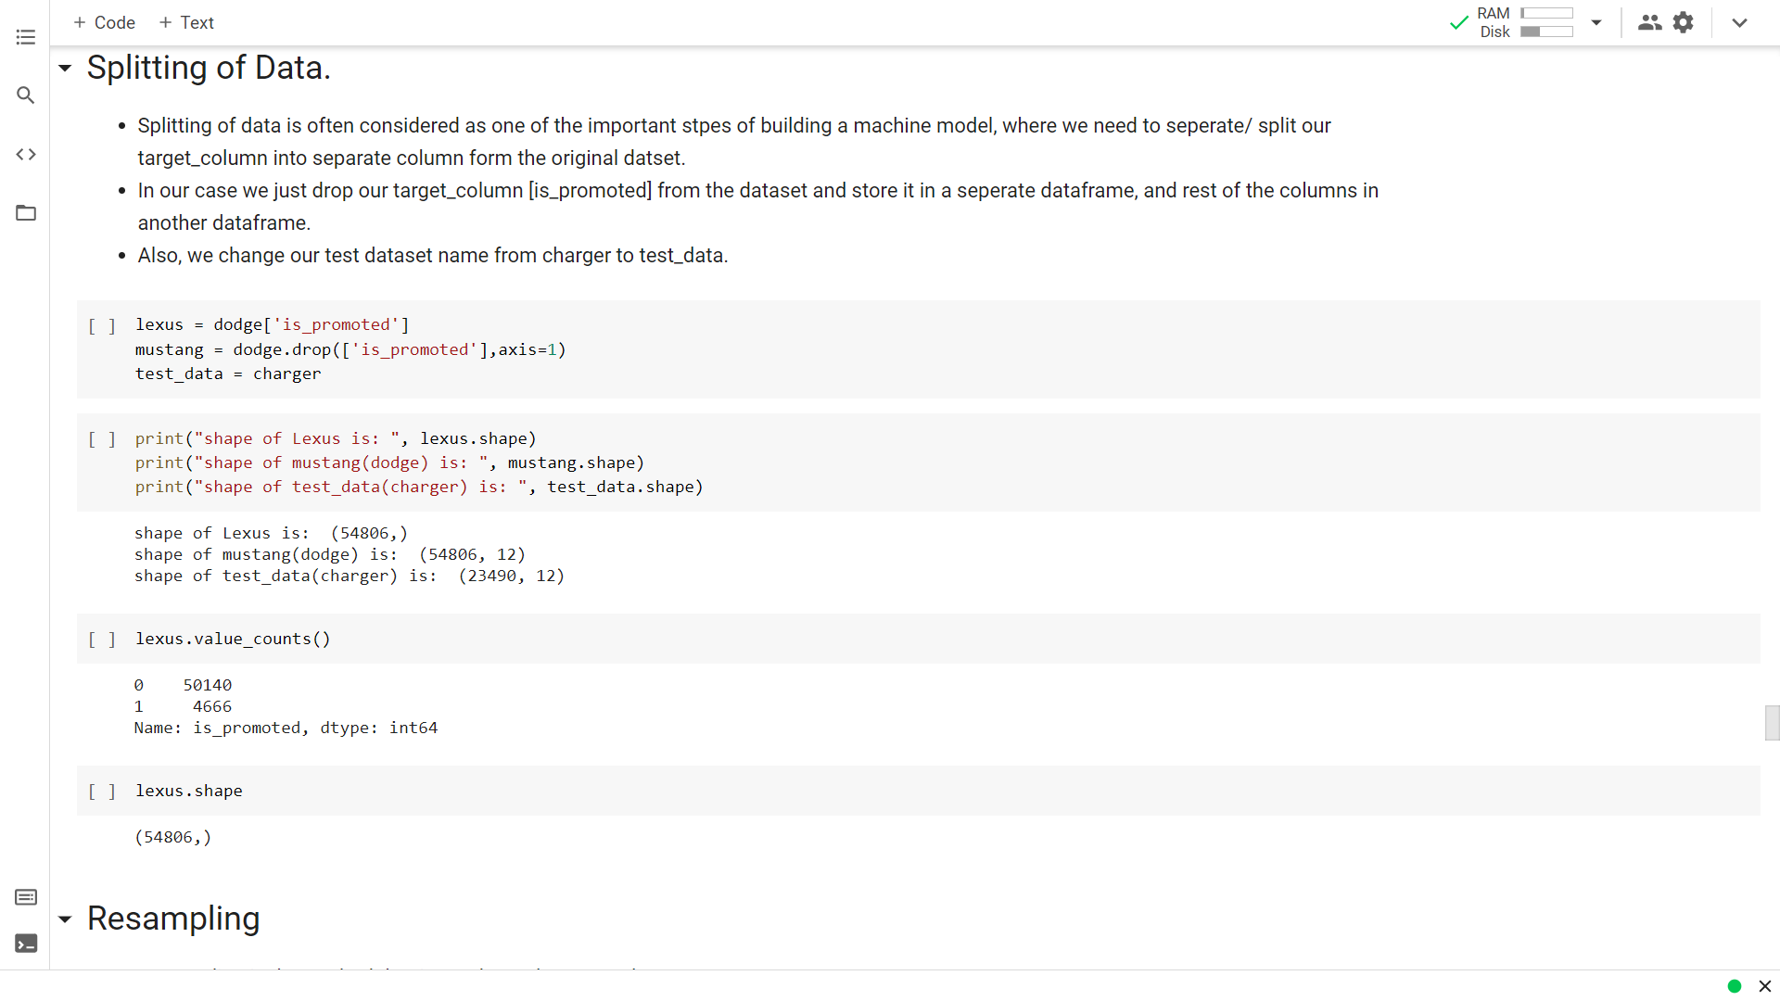
Fig 3.6 Splitting of Data.
Resampling

Resampling is the method that is used to Balance our dataset.

This Resampling comes to handy whenever our variables/columns are highly imbalanced, so we need to balance them by using some of these resampling methods, in our case we have seen that our target variable is highly imbalanced.
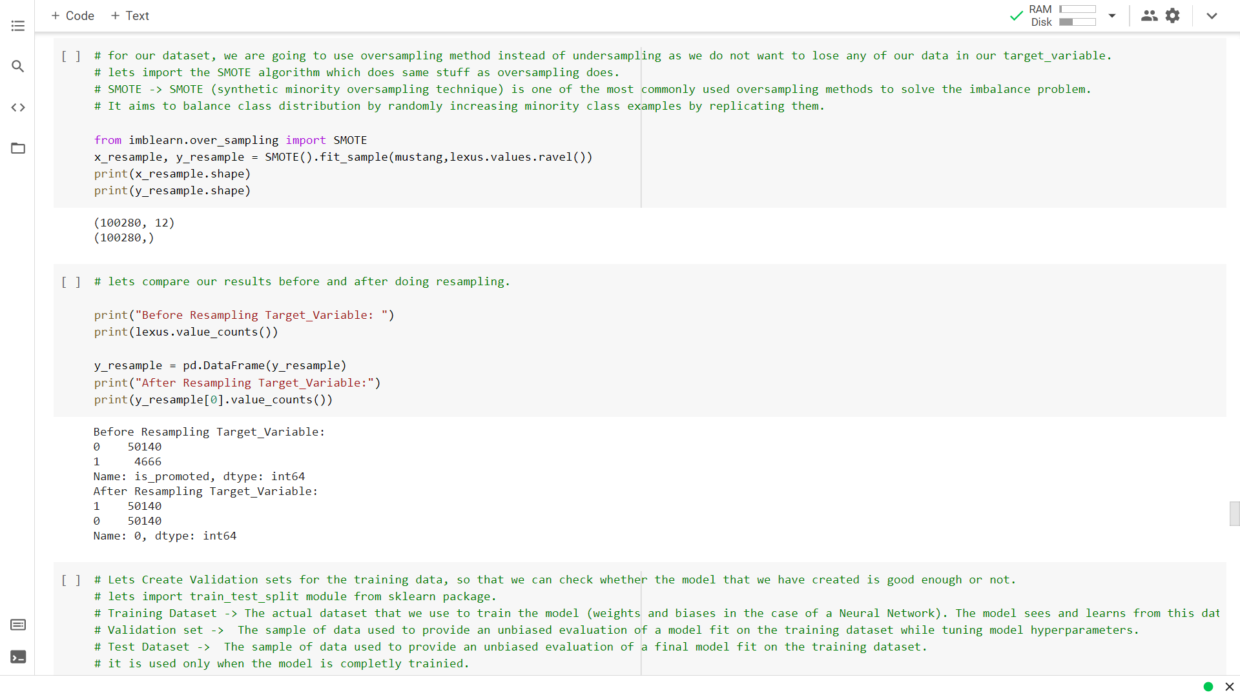
Fig 3.7 Resampling Data.

Feature Scaling:
Feature scaling is the method of scaling the features in our dataset, so that the higher values doesn't dominate the lower values. Scaling can make a difference between a weak machine learning model and a better one.

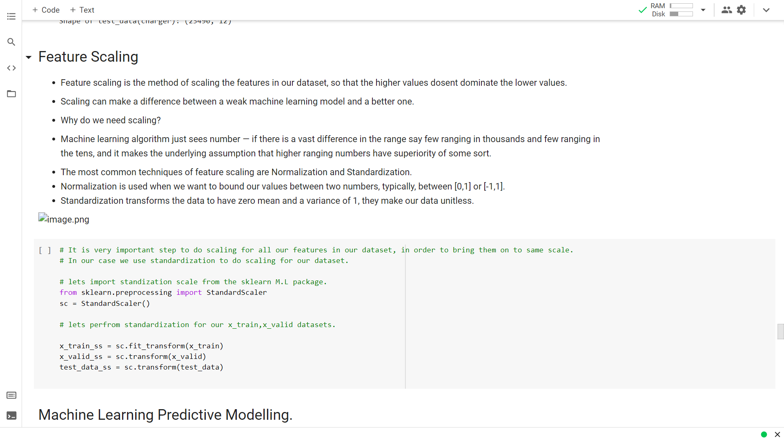
Fig 3.8 Feature Scaling

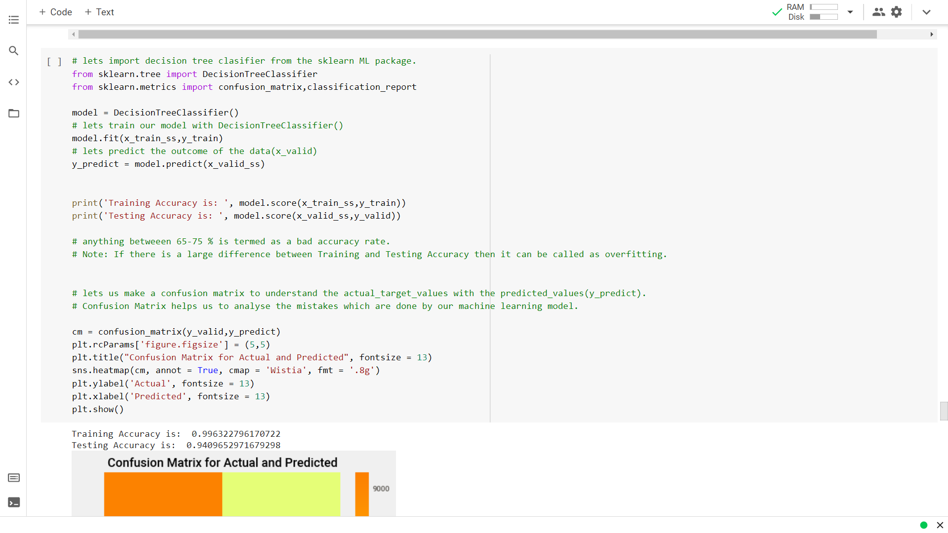
Fig 3.9 Decision Tree Model

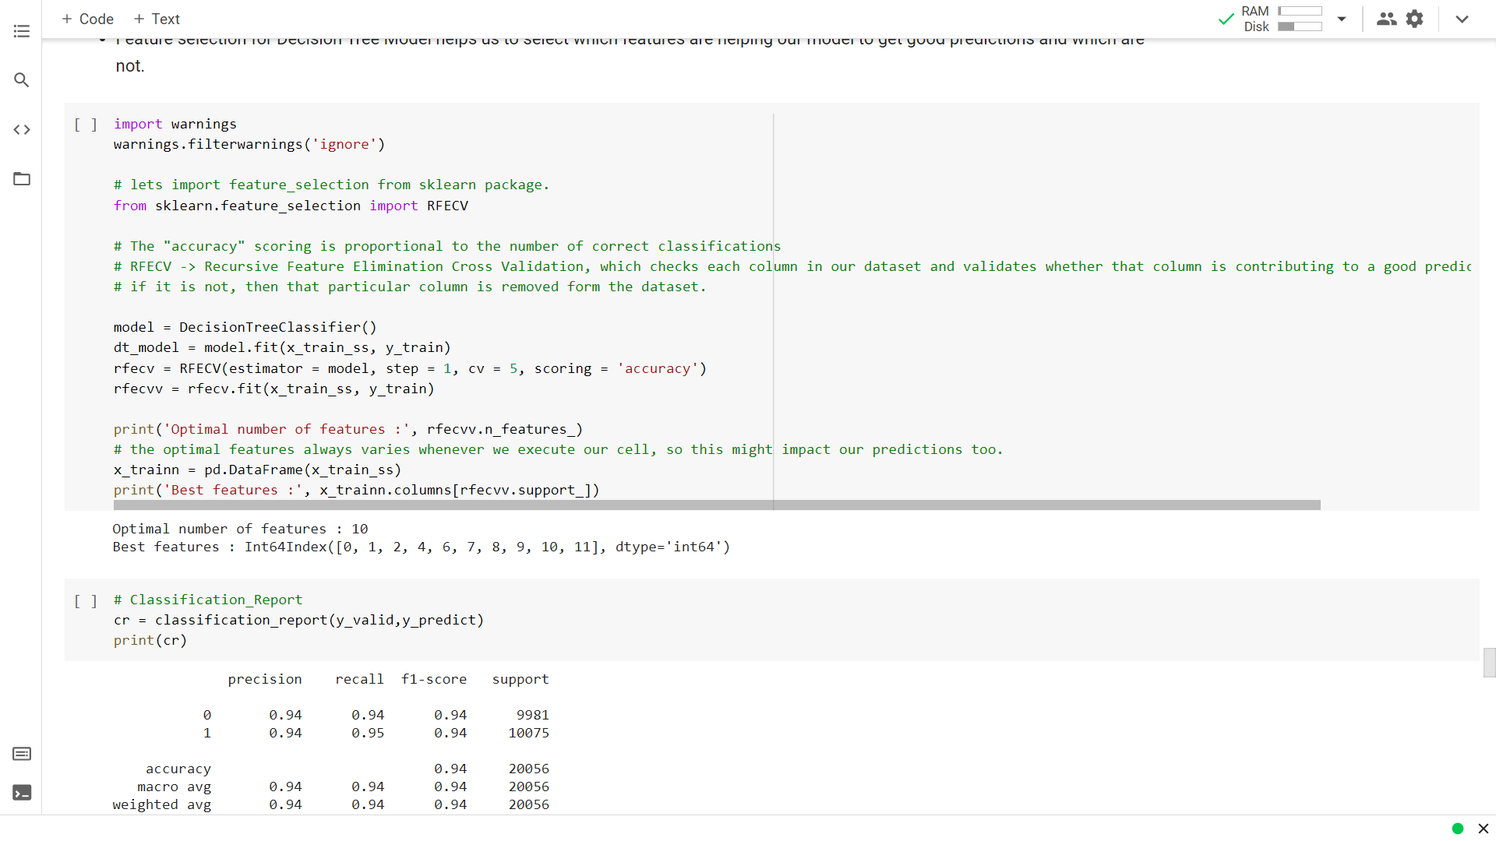
Fig 4.1 Decision Tree Report

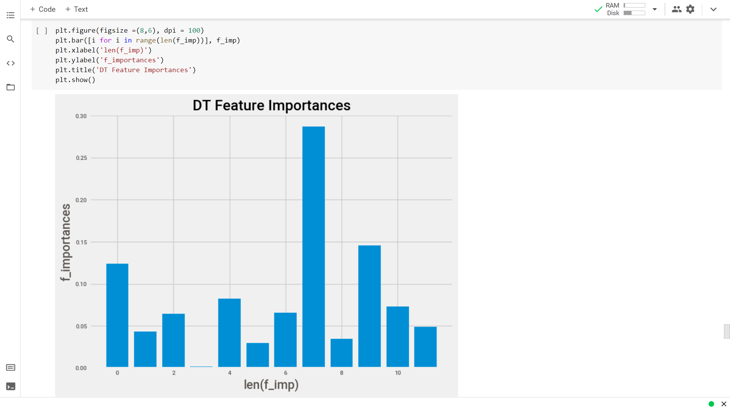
Fig 4.2 Decision Tree Feature Importance using (dt_model.feature_importances_)

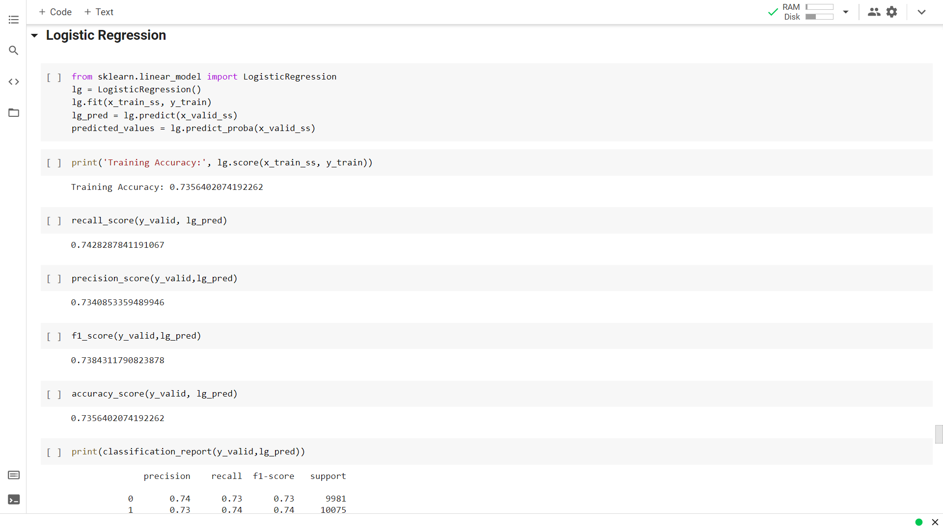
Fig 4.3 Logistic Regression Report

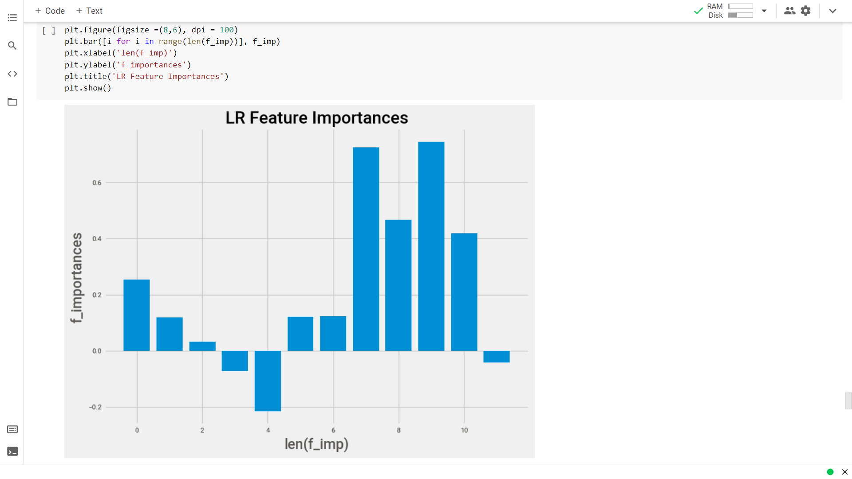
Fig 4.4 Logistic Regression Feature Importance using (f_imp = lg.coef_[0])

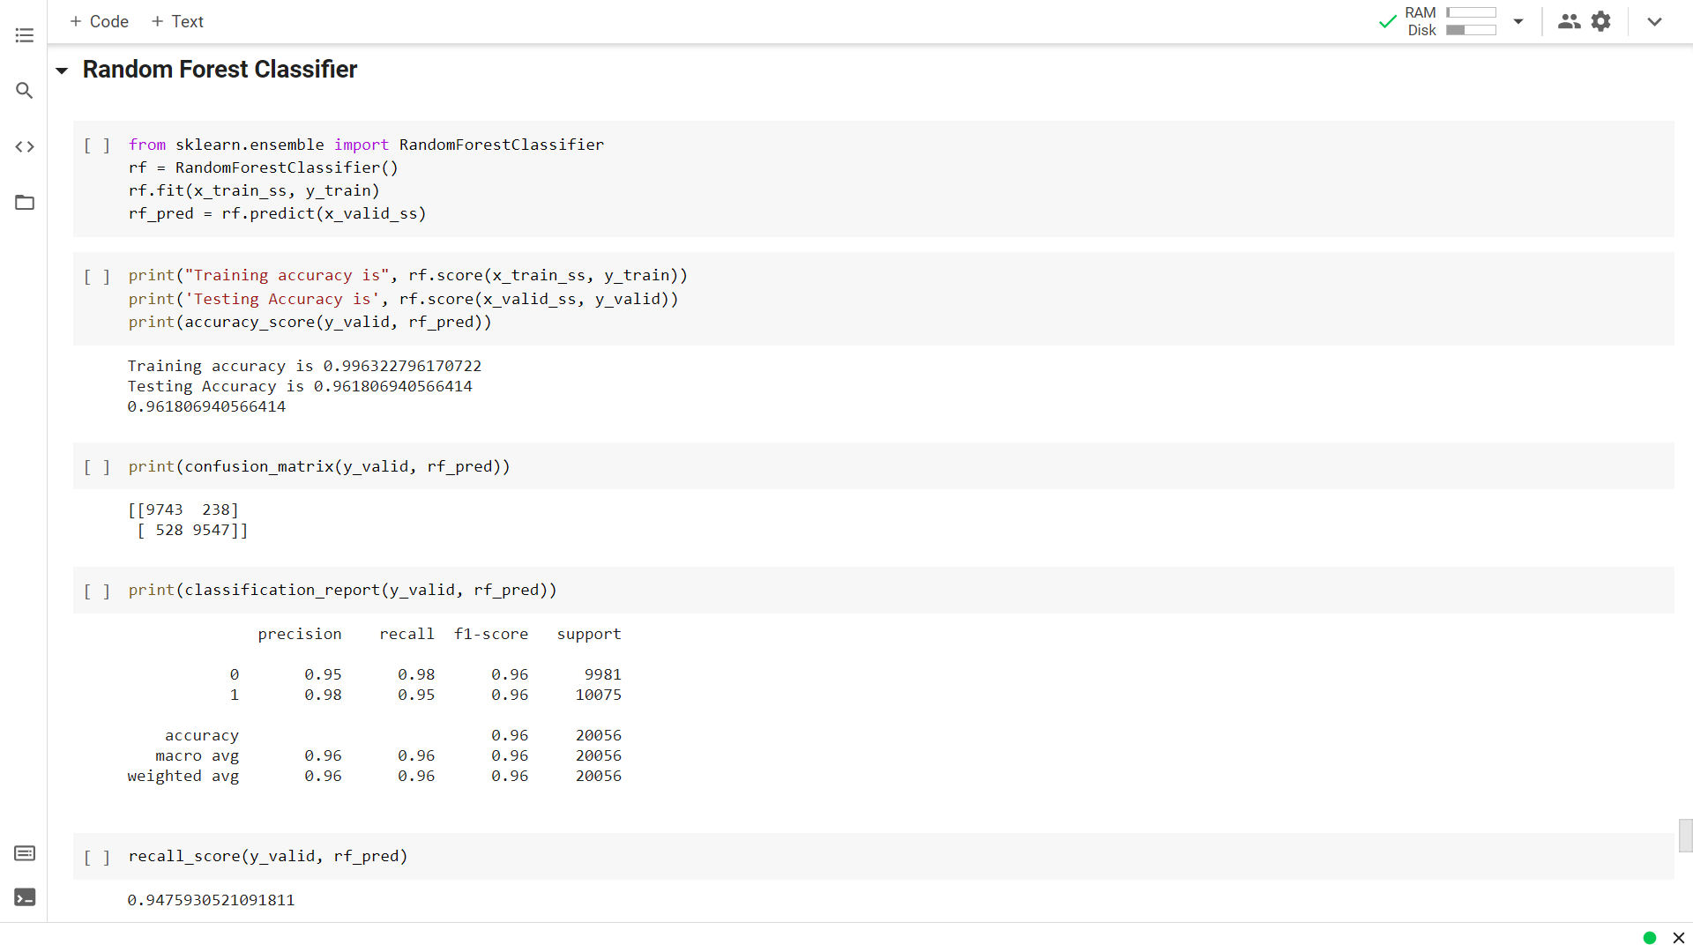
Fig 4.5 Random Forest Classifier Report

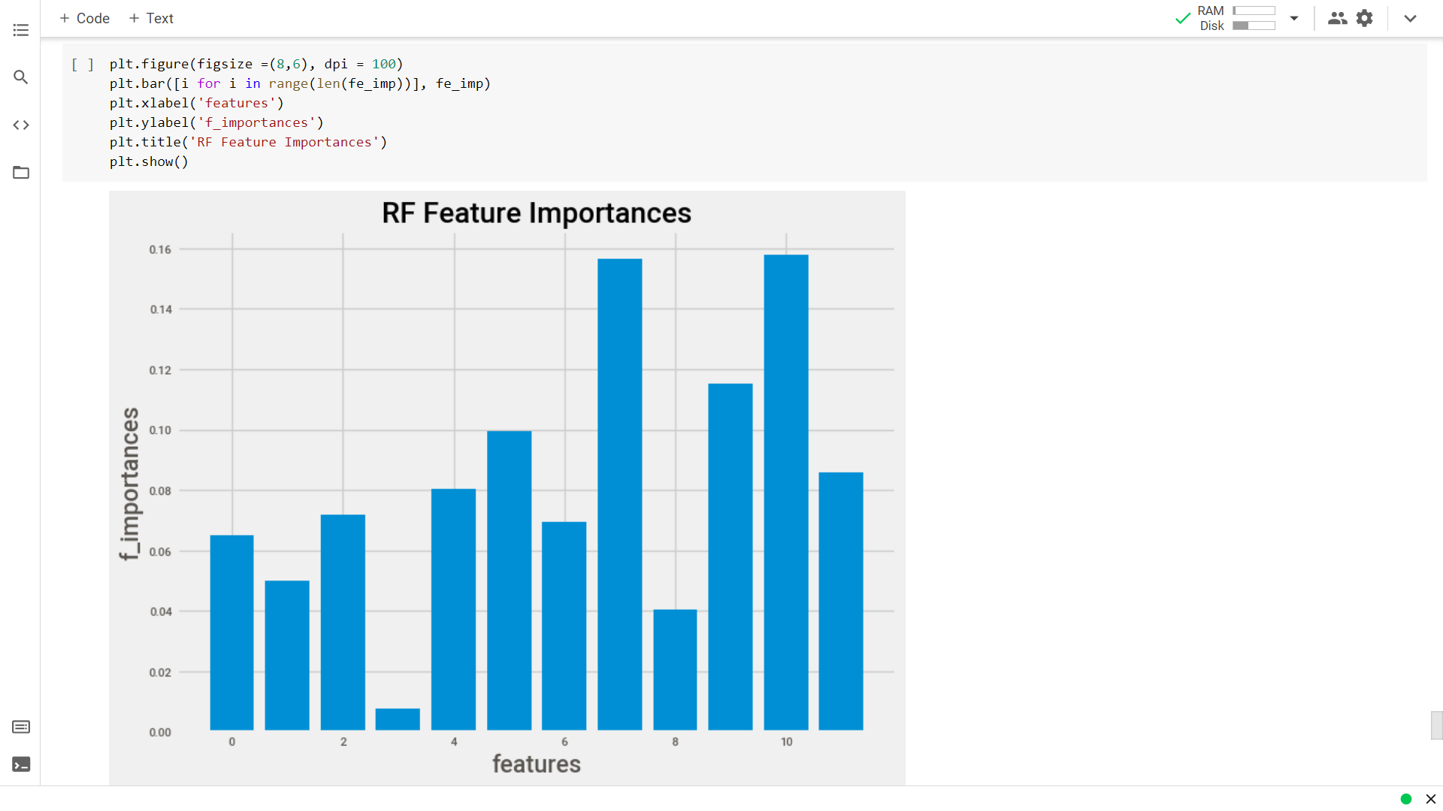
Fig 4.6 Random Forest Feature Importance (fe_imp = rf.feature_importances_)

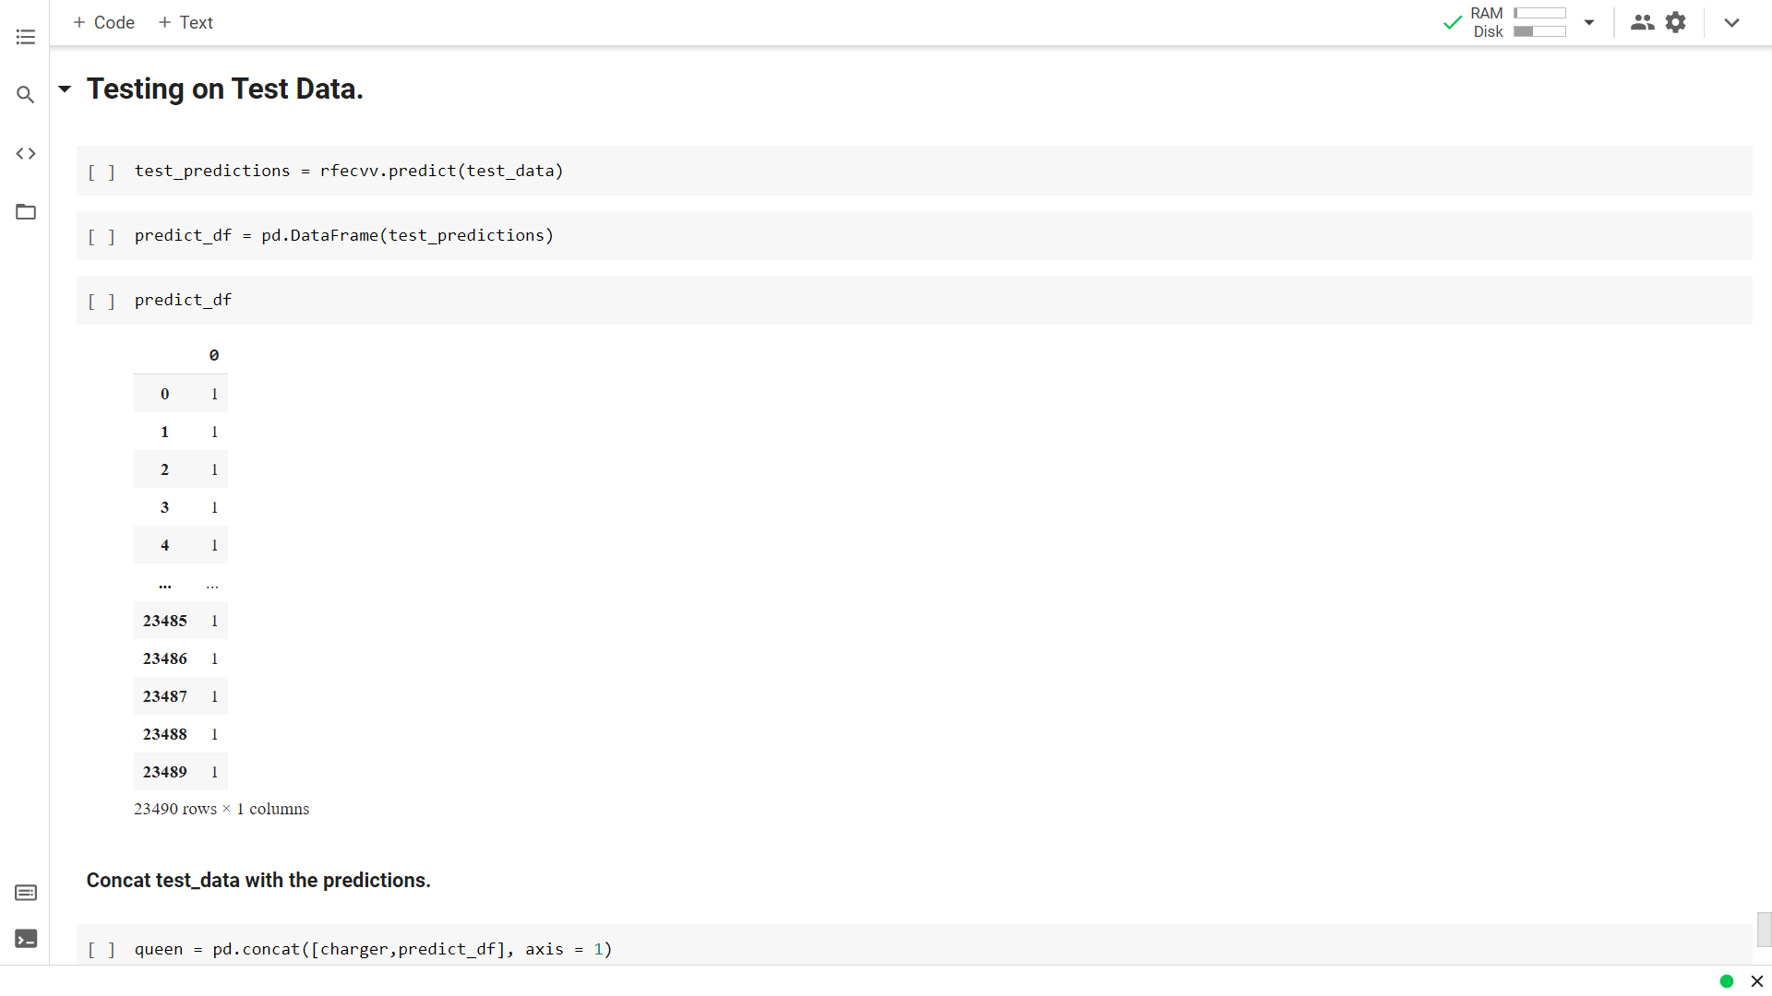
Fig 4.7 Testing on Test Data.

CONCLUSION AND FUTURE SCOPE

Conclusion
This project entitled “Employee Promotion Criteria analysis using Deep Learning and Machine Learning.” is useful to identify the employees suitable for promotion. The project is very useful to the Human Resources Department, in accurately determining the employees to be promoted. The project is also useful to the hard-working employees, as their efforts are properly recognized by the tool, while determining the promotions. This project finally leads to the quality of the working environment in organizations. Many problems are already solved using Predictive model, some of the best use of Predictive models in the industry are in
- Finance
- Healthcare
- Heavy Industry
- Transport
- Consumer goods

Future Work
Although data sampling is an efficient way to augment the data, it may still be non representative of real-world. Further studies are necessary to determine if the conclusion holds. It is also recommended to extend this research to include more baseline models with a focus on feature engineering, i.e. using different data encoding and scaling methods.

REFERENCES

- Bottou, Léon. "Large-scale machine learning with stochastic gradient descent." Proceedings of COMPSTAT'2010. Physica-Verlag HD. 177-186.
- https://www.kaggle.com/
- https://www.youtube.com/channel/UCNU_lfiiWBdtULKOw6X0Dig
- https://medium.com/topic/machine-learning
- https://towardsdatascience.com/
- https://duckduckgo.com/?t=brave

